3.1. DiverSea Catalogue
This section provides technical details about accessing DiverSea catalogue, which is part of DiverSea project site on GitHub. The catalogue is the entry point into DiverSea Data Space and provides public view at all resources in the data space and the project. It provides information about the data in the data space from several perspectives – archiving, geolocating, browsing, searching, and contextual exploration, which serve different purposes (Fig. 1).
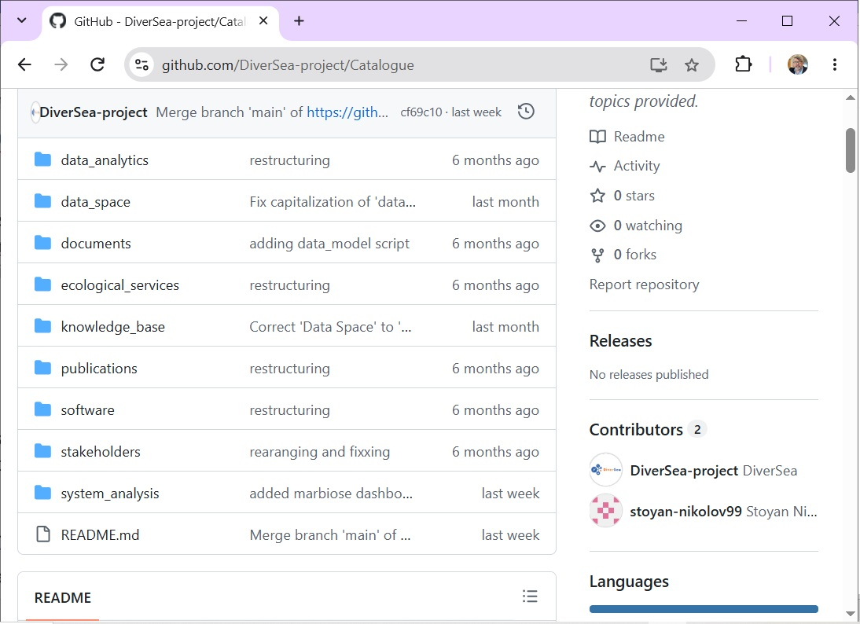
Figure 1. The main page of DiverSea catalogue on GitHub
DiverSea catalogue is a Web site accessible over the Internet using a standard Web browser without preliminary registration at
https://github.com/DiverSea-project/Catalogue
The catalogue is entirely public and does not require any credentials from the user to view it without modification. Administrator of the catalogue is the DiverSea Data Space administrator (email: stoyan.nikolov@gate-ai.eu).

